Statement of completeness:
Shared Games Class Library
-Added in 3 variables to CardPile
- public Const int Num_Suits = 4
- public Const int Num_Cards = 13
- Random variable

Games Class Library:
Crazy Eights UML Class Diagram
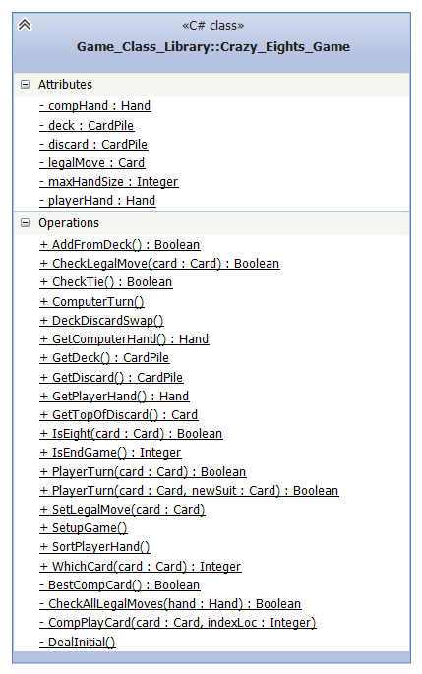
- Generated from the Microsoft Visual Studio UML Diagram Builder

Crazy Eights working as intended. The game restarts at end of game, resetting the deal and sort buttons. If deal is clicked again, a fresh instance of the game is created.

Solitaire:

Solitaire form is loading and starting a game, however the game crashes on selecting a card. Game logic built to move hands around on the form.
Features left to implement:
- Fix moving cards from pile to pile
- Moving card from current top of deck to pile
- Implementation of the suit piles

